CASE STUDY
Concepts and definitions of employment
indicators relevant for young people

This case study is based on “External Evaluation of YDP and NUYEP Programmes: Final Evaluation Report, 23rd September 2016” and “Northern Uganda Youth Entrepreneurship Project Review 2013-2016”.
- Introduction and case study context
Uganda has one of the fastest-growing populations in the world. Over three-quarters of Ugandans are under the age of 30, implying a demographic with great economic and social potential. Yet many young Ugandans frequently find themselves without opportunities for sustainable work. Unemployment, underemployment and working poverty are a widespread phenomenon. Young women, in particular, face social and economic barriers due to cultural norms and sexual harassment.
In Northern Uganda, a 20-year-long civil war has left the local population with additional economic, social and psychological challenges. Young people suffered disrupted schooling and communities were displaced. The legacy of war continues to limit opportunities in the labour market. Youth unemployment rates are high. Employment in the informal sector is common.
The Government of Uganda has put in place a policy to promote the development of Micro, Small and Medium Scale Enterprises (MSMEs) to become the main vehicle for expanding production, providing sustainable jobs and enhancing economic growth. A new MSME Directorate in the Ministry of Trade, Industry and Cooperatives saw entrepreneurship education and training as one means to remedy the problems faced by young people in Northern Uganda. It recognised both the lack of waged employment opportunities in the private sector and sought to build participants’ capacity to start up income-generating activities and become self-employed. In this context, the UK Department for International Development (DFID) supported the government objectives by funding the Northern Uganda Youth Entrepreneurship Programme (NUYEP).
This case focuses on choosing appropriate labour market indicators relevant to young people that can be used in the monitoring and evaluation frameworks of NUYEP.
. By the end of this case, readers will be able to demonstrate the following learning outcomes:
- Identify the relevant dimensions of youth employment, from: Employment opportunities, employment quality, employment access and employment skills.
- Be able to navigate and select from a ‘menu’ of indicators to select from based on the objectives and design of the youth employment intervention.

Selecting indicators
The Northern Uganda Youth Entrepreneurship Programme (NUYEP) aims to support 10,500 beneficiaries, 80% of whom are youth (aged 18-35). The programme targets five conflict-affected sub-regions in the North of Uganda with a view to improving the livelihoods of young people and their households through entrepreneurship.
Analysis conducted by NUYEP during programme design revealed that previous interventions in the sub-regions had a focus on children, women and people with disabilities, while youth needs were largely ignored. Further, a survey of female youth by UNICEF showed that incomes and employment among young women are especially low with the majority of young women earning less than 1 US dollar a day. Young women with children or orphans, single mothers, former abductees and victims of gender based violence were identified as most in need of livelihood interventions.
NUYEP plans an approach that emphasises starting and running an enterprise, transforming unemployed and under employed youth and their household members into business owners with an improved flow of income. The programme is based on a 6 step cycle:
- Stage 1: Entrepreneurship Awareness and Mobilisation
- Stage 2: Business and Enterprise Start-up Tool (BEST), mass training workshop
- Stage 3: BEST follow up workshops, offering follow-on support
- Stage 4: Specialised Business Skills Clinics
- Stage 5: One-on-one Volunteer Mentoring and Business Counselling Services
- Stage 6: Linkage to Finance, with a focus on Savings and Investment Clubs and Savings and Credit Co-operatives (SACCO)
Participants were those who were willing to invest an initial amount of their own money to receive Business and Enterprise Start-up Tool (BEST), which is delivered through mass-training events of up to 800 participants in a purpose-built marquee over five days. The ‘high flyers’ then self-selected to receive more intensive levels of support during stages 3 to 6.
These outputs are expected to lead to the main outcome of the project which is creation and expansion of 6,000 youth or family owned businesses in Northern Uganda, of which 1,000 create additional jobs. This is expected to contribute to a peaceful and productive youth population with improved livelihood in Northern Uganda
DISCUSSION TOPICS
- NUYEP wants your help to select appropriate outcome and high-level goal indicators to measure the success of their project. The first step is to decide which key dimension of decent jobs to measure . Which would you recommend – and why?

Facilitator guidance
All of them could be relevant! The important thing is to have participants justify their selection with a sound logic, which links back not only to the project objective, but to the nature of the intervention (the 6 step cycle).
Employment creation is clearly relevant, and stated in the project outcome. As is job quality – particularly incomes – as the objective calls for the expansion of youth - and family-owned businesses. Core employment skills are being created through mentoring and clinics: Not just hard skills, but soft skills such as self-confidence may be relevant at well. Given the disproportionate barriers faced by young women, employment access should also be considered.
In reality, the NYEP placed a great deal of emphasis on employment access and skills. The project theory of change included:
• Changes in youth’s mind-set and attitude from reliance to self-confidence;
• Increased motivation for youth to act;
• Youth will be equipped with an understanding of business planning, local market, financial literacy and opportunities;
• Female youth are supported to overcome barriers to successful implementation.

- Which indicators would you recommend that NUYEP measures?
Facilitator guidance
There are a number that could be chosen in area of the three dimensions, as per the table below. However, participants should be encouraged to focus – and pick no more and 2-3 maximum per outcome to avoid measurement becoming impractical, burdensome and costly.
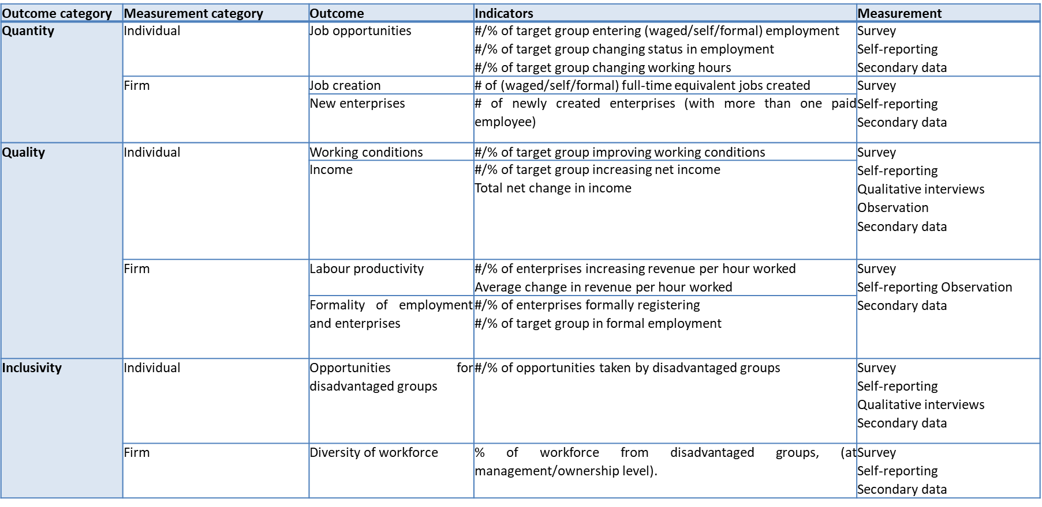
In reality, NUYEP was constrained by the donor-mandated project logframe, which stipulated a single outcome indicator: Number of YDP youth with decent jobs (employed or self-employed in the formal or informal economy).
Without a standard definition of what a ‘decent job’ looks like, this NUYEP considered it as employment for more than six months, working for 40 hours a week with earnings of more than 141,000 Ugandan shilling per month. However, the final evaluation noted that this was unachievable for the majority of the participants taking into consideration the market conditions and economic environment of Northern Uganda.
This demonstrates the difficulty in coming up with a single composite employment indicator that can capture the multi-dimensional nature of decent work. Selecting a handful of indicators across the relevant dimensions is therefore likely to be both more measurable and meaningful.

- NUYEP needs particular help with ‘quantity of employment’. They want your guidance on how to define and measure each key indicator. What would you advise?
Facilitator guidance
Included below are pointers to guide discussion among participants, depending on which indicators they choose to focus on:
Percent of firms formally registered
- What counts as formal registration? (this should be registration with the relevant government authority, not registration with the development project)
Number of employed project beneficiaries
- What constitutes employment? (the answer is work performed for wage or salary in cash or in kind, or for profit or family gain)
- What reference period should be used to ask respondents – whether they worked in last day, week or month? (Suggested time is norammly 2 weeks. A reference period that is too short (e.g. one day) risks respondents being temporarily absent from work during the reference period, due to a holiday etc., while too long (months) risks poor recall.
Number of full-time equivalent (FTE) jobs
- What counts as one FTE? (Recommendation is 40-hour working week)
- How should part-time jobs be counted? (The answer is part-time jobs are converted to full-time equivalent jobs on a pro rata basis, based on local definition - e.g. a 24 hr/week job would be equal to 0.6 FTE job)

NUYEP was implemented by Enterprise Uganda (EUg) in partnership with Youth Business International (YBI), and ran from 2013-2016

